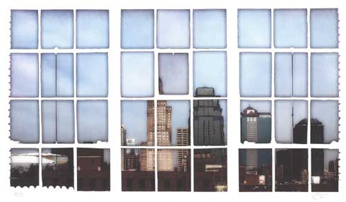**ENVIRONMENTAL MANAGEMENT COMMISSION AGENDA**

Wednesday, June 08, 2022, 4:00 p.m. to 6:00 p.m.

|  |  |
| --- | --- |
| MEETING ACCESS THIS MONTH | Microsoft Teams meeting  **Join on your computer or mobile app**  [Click here to join the meeting](https://teams.microsoft.com/l/meetup-join/19%3ameeting_MDE2NWFmNmUtNWMxOS00NjllLTlmMWUtNzNlZTBmMzcxOGFj%40thread.v2/0?context=%7b%22Tid%22%3a%22ec240911-5979-4419-a8ec-c808b076019b%22%2c%22Oid%22%3a%22d9a26f79-b297-4077-a993-7407750cb514%22%7d)  **Or join by entering a meeting ID** Meeting ID: 230 766 612 409  Passcode: 3RBbni  **Or call in (audio only)**  [+1 872-212-5076,,896984956#](tel:+18722125076,,896984956# )   United States, Chicago  Phone Conference ID: 896 984 956#  [Find a local number](https://dialin.teams.microsoft.com/1ed7a2c0-9103-4d5d-9027-4f1a88a06d98?id=896984956) | [Reset PIN](https://dialin.teams.microsoft.com/usp/pstnconferencing)  [Learn More](https://aka.ms/JoinTeamsMeeting) | [Meeting options](https://teams.microsoft.com/meetingOptions/?organizerId=d9a26f79-b297-4077-a993-7407750cb514&tenantId=ec240911-5979-4419-a8ec-c808b076019b&threadId=19_meeting_MDE2NWFmNmUtNWMxOS00NjllLTlmMWUtNzNlZTBmMzcxOGFj@thread.v2&messageId=0&language=en-US) |

1. Introductions 5 minutes
2. Review & Adoption of May 2022 Minutes * 5 minutes
3. Solarize KC 20 minutes
4. Office of Environmental Quality Report - Andy Savastino 15 minutes
5. Annual Report 60 minutes
6. Old Business 5 minutes
7. New Business 5 minutes
8. Remarks from Visitors 5 minutes

Adjourn

*Action Items

Next meeting: Wednesday, July 13, 2022 - 4:00 p.m. to 6:00 p.m.

Location: TBD