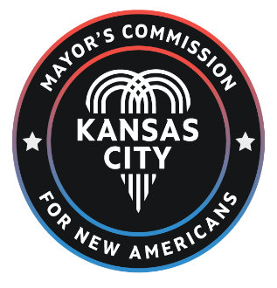

MEETING NOTICE
Notice is hereby given that the Mayor’s Commission for New Americans will conduct a meeting at 6 p.m. on Thursday, September 19th, 2024 Via Zoom Please click this URL to join. https://us02web.zoom.us/j/84758311443 Webinar ID: 847 5831 1443 Or One tap mobile: +13126266799,,84758311443# US (Chicago) +16469313860,,84758311

The tentative agenda of this meeting includes:
- Call to order
- Office of Immigration and Refugee Affairs
  - Report Review
  - Recommendation Preparation
- Other Business
- Adjourn

